PONTYPRIDD TOWN AFC 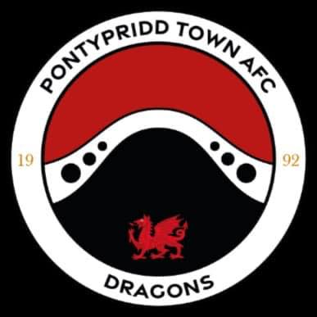
REGULATIONS ON THE USE OF SOCIAL MEDIA
1. Introduction
1.1. Social Media is defined as “websites and applications that enable users to create and share content or to participate in social networking”.
1.2. Pontypridd Town AFC recognises that the use of Social Media can have a positive impact on the promotion and accessibility of football. The club promotes within these Regulations the participation in these online communities and encourages every Member and/or Subordinate to exercise respect, responsibility and integrity when using Social Media.
1.3. These Regulations are designed to ensure the responsible use of Social Media Platforms by all those involved in football under the jurisdiction of Pontypridd Town AFC. This Regulation aims to prevent the use of Social Media in any way which may be harmful to the interests of Pontypridd Town AFC and club partners. It is the club’s intention to take vigorous action against
individuals who act in any way in contravention of this Regulation.
2. Social Media Platforms
2.1. For the purpose of these Regulations, Social Media Platforms will include (without limitation) the following:
2.2.1. Twitter;
2.2.2. Facebook;
2.2.3. MySpace;
2.2.4. LinkedIn;
2.2.5. Instagram;
2.2.6. YouTube;
2.2.7. Blogs; and
2.2.8. Forums.
Pontypridd Town AFC recognises that there are numerous Social Media Platforms available and the above list is not intended to be exhaustive. Live broadcasts and/or recordings will also be subject to these Regulations.
3. Scope
3.1. Where there is sufficient evidence of an offence as specified under this Regulation, the individual concerned will be dealt as the club feels appropriate and in conjunction with the Rules & Regulations of the Football Association of Wales

Offence
4.1. It shall be a breach of these Regulations if any Member and/or Subordinate publishes or share’s, on any Social Media Platform, anything which:
4.1.1. implies bias of any player, club, club official, match official, league, league official, Area Association, Area Association official, club partners, or the FAW;
4.1.2. questions the integrity of the club and/or any Member and/or Subordinate;
4.1.3. is offensive, abusive, insulting, threatening, derogatory or of a personal nature which is likely to cause offence at any time.
4.1.4. is intended to harass another Member and/or Subordinate. Harassment is defined as systematic, hostile and repeated acts for a considerable duration, intended to isolate or ostracise a Member and/or Subordinate and affect the dignity of that Member and/or Subordinate;
4.1.5. brings the club and/or the game of Association Football or all other forms of football into disrepute.
4.2. For the avoidance of doubt, any Member and/or Subordinate will be held responsible for any comments made that are recorded and/or streamed live, which are directly or indirectly published or broadcast to a wider audience.
4.3. Any Member and/or Subordinate who posts, on any Social Media Platform, a post which is deemed to be of a discriminatory nature, as defined by section 3.1 of the Non-Discrimination Regulations, may be dealt with as the club sees fit and reported to the FAW pursuant to the FAW Non-Discrimination Regulations.
4.4. Upon receipt of a report that any Member and/or Subordinate may have in any way contravened this Regulation, the club will investigate and decide on the appropriate action to be taken.
4.5. Any Member and/or Subordinate who is deemed to be in breach of this Regulation may also be reported for Disciplinary action to the FAW
4.6. You are also reminded that, in certain circumstances, breach of this Regulation may also constitute a criminal offence.

